**Spatial-Spectral Processing**

**Homework 4 – Remote Sensing**

**Due Date: Julio 13, 2021**

**Problem 1:** Using the classification maps obtained in the *Problem 1 of HW3* for Indian Pines and Pavia University hyperspectral images, apply a majority vote approach to improve the classification results. For spatial windows of 3x3, 5x5, and 9x9, select the most common label as the class for the center pixel. For each image and window size present (a) confusion matrix, (b) classification map, and (d) a discussion of your results and the comparison with the obtained in HW3.

**Problem 2:** Implement a segmentation method for hyperspectral imagery (you can use Matlab and Python code from the web). Apply the segmentation to Indian Pines and Pavia University. This segmentation will be use to improve the spectral classification. Include in the report the segmented images.

**Problem 3:** Using the segmented images from Indian Pines and Pavia University, implement a spatial-spectral classification approach with the framework presented in the Figure 1. For the pixel-wise classification, use the results obtained in HW3.

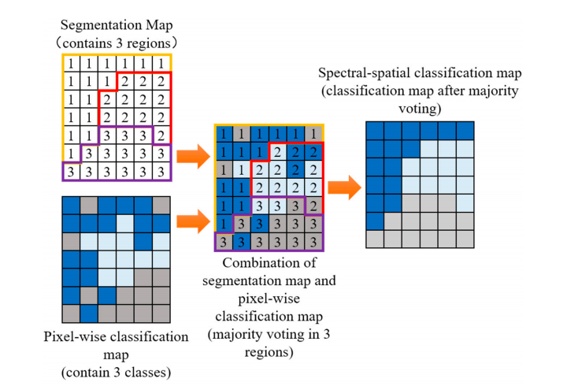Figure 1: Spatial-spectral classification approach

For each image and window size present (a) confusion matrix, (b) classification map, and (d) a discussion of your results and the comparison with the obtained in HW3 and problem 1.